Install Google Chrome on Ubuntu 16.04 LTS from the Command Line
For those of you who like to hone their command line skills, here is how to install Google Chrome on Ubuntu 16.04 using terminal.
Press CTRL+ALT+T to open a terminal window, then edit sources.list file with nano text editor. You need to enter your password.
sudo nano /etc/apt/sources.list
Use the down arrow key to scroll to the bottom of this file. Copy the following APT line and paste it at the end of the file.
deb [arch=amd64] http://dl.google.com/linux/chrome/deb/ stable main
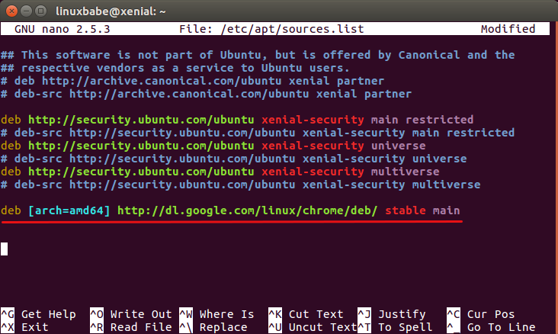
Press CTRL+O to save the file. Then press CTRL+X to exit out of this file. After that, enter the following command to download Google’s signing key.
wget https://dl.google.com/linux/linux_signing_key.pub
Then use apt-key to add it to your keyring so the package manager can verify the integrity of Google Chrome package.
sudo apt-key add linux_signing_key.pub
Now update package list and install the stable version of Google Chrome.
sudo apt update

sudo apt install google-chrome-stable
If you want to install the beta or unstable version of Google Chrome, use the following commands:
sudo apt install google-chrome-beta

sudo apt install google-chrome-unstable
Google Chrome browser Linux version ships with a built-in flash player called Pepper Flash installed under /opt/google/chrome/PepperFlash directory.
As you can see, installing Google Chrome browser on Ubuntu 16.04 is easy! Comments, questions or suggestions are always welcome. If you found this post useful, please share it with your friends on social media! Stay tuned for more Linux tutorials.

